

Carrie Greenwood
Chair
Topeka, KS
carrieg@kyea.org

Anthony Frischenmeyer
Vice-Chair
Hutchinson, KS
afrischenmeyer@
beyondbarriersks.com

Macy Collins
Treasurer
Towanda, KS
macy.gaines@rcilinc.org

Laura Denny
Secretary
Hays, KS
laurad@linkinc.org

Julia Connellis
Abilene, KS
jconnellis@occk.com

Adam Burnett
Osage City, KS
adam@rcilinc.org

Tamara Blackwell
Bel Aire, KS
tam@
mswheelchairamerica.org

Rex Ellebracht
Lawrence, KS
rellebracht@
independenceinc.org

Billie Crawshaw
La Cross, KS
Billie.Crawshaw@ks.gov

Kim Dietrich
Topeka, KS
Kim.Dietrich@rcilinc.org

Chris Testorff
Yates Center, KS
christestorff@yahoo.com

Ashley Wolfrum
Junction City, KS
ashleyw@threeriversinc.org

Empowerment In Action: Shaping Our Future

To Whom It May Concern,

The Kansas Disability Caucus board of directors would like to invite you to support one of the premier disability conferences in the state of Kansas by becoming a sponsor of this year’s Kansas Disability Caucus, taking place August 12th - 14th in Topeka. We will bring together more than 200 people with disabilities from all over Kansas to learn about issues facing the community and develop solutions to these issues.

Since 1988, this event has been the catalyst to significant changes for people with disabilities in Kansas, including the passage of the first consumer directed personal assistance program, as well as the Working Healthy Medicaid buy-in program allowing people with disabilities to work without fear of losing their health insurance. With your support participants will learn from each other, engage in peer support, develop advocacy priorities for themselves, and come together creating a sense of belonging. I cannot think of a better occasion that provides a place for people with disabilities to feels supported and encouraged.

By becoming a sponsor, you will be providing scholarships for people with disabilities to attend! Enclosed, please find the available sponsorship levels and the benefits provided at each level. Do not let this opportunity pass you by – the deadline is June 30th. Support us in 2026, as the Caucus only occurs every two years!

Thank you for your consideration and we look forward to hearing from you.
If you have questions, please feel free to contact me at 316-322-7853 or macy.gaines@rcilinc.org

Sincerely,

Macy Collins
Kansas Disability Caucus Treasurer

The Kansas Disability Caucus’ purpose is to plan, organize and
coordinate activities that promote independent living through
collaboration, networking, education, planning, and peer-to-peer
interaction.

WWW.KANSASDISABILITYCAUCUS.ORG


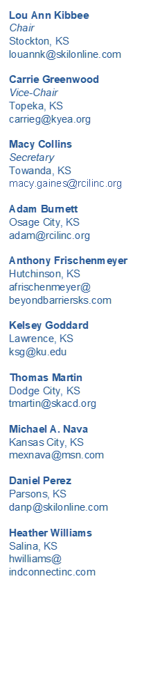

Empowerment In Action: Shaping Our Future

Please make checks payable to:

Kansas Disability Caucus

120 S. Gordy #3
El Dorado KS 67042
2026 Sponsor Packages

Platinum ------ $15,000.00

- Full page ad in Kansas Disability Caucus program
- Preferential exhibitor space at Banquet Hall entrance
- Verbal and written sponsorship acknowledgement
- Opportunity to place your company's items in participant bags
- Gratitude for providing 50 conference participants scholarship funding
- 5 Complimentary registrations & 5 designated seats at banquet

Gold ------ $10,000.00

- Full page ad in Kansas Disability Caucus program
- 2 Complimentary exhibitor tables
- Verbal and written sponsorship acknowledgement
- Opportunity to place your company's items in participant bags
- Gratitude for providing 30 conference participants scholarship funding
- 3 Complimentary registrations & 3 designated seats at banquet

Silver ------ $5,000.00

- Full page ad in Kansas Disability Caucus program
- 1 Complimentary exhibitor table
- Opportunity to place your company's items in participant bags
- Gratitude for providing 15 conference participants scholarship funding
- 2 Complimentary registrations & 2 designated seats at banquet

Bronze ------ $2,500.00

- Half page ad in Kansas Disability Caucus program
- Half price exhibitor table
- Written sponsorship acknowledgement
- Gratitude for providing 5 conference participants scholarship funding

Do not let this opportunity pass you by –
The deadline for sponsorship is June 30th.

WWW.KANSASDISABILITYCAUCUS.ORG

